**Polycystic Ovary Syndrome Prediction Through CNN Based Image Analysis: A Deep Learning Based Approach**

1st Sruthi R  
*M.Sc. in Data Science (Integrated)*  
*Department of Computing - Data Science**Coimbatore Institute of Technology*Coimbatore, Tamil Nadu, India  
[2032043mds@cit.edu.in](mailto:2032043mds@cit.edu.in)

2nd Yazhini Karthik  
*M.Sc. in Data Science (Integrated)*  
*Department of Computing - Data Science  
Coimbatore Institute of Technology*Coimbatore, Tamil Nadu, India  
[2032051mds@cit.edu.in](mailto:2032051mds@cit.edu.in)

3rd Dr. Sujithra M  
*Associate Professor*  
*Department of Computing - Data Science  
Coimbatore Institute of Technology*Coimbatore, Tamil Nadu, India  
[sujithra@cit.edu.in](mailto:sujithra@cit.edu.in)

***Abstract***—**Polycystic Ovary Syndrome (PCOS) is a prevalent hormonal disorder affecting women during their reproductive years. It is characterized by irregular menstrual cycles, excessive hair growth, and the presence of cysts in the ovaries. The diagnosis of PCOS typically involves a combination of clinical evaluations and laboratory tests. The paper proposes a novel approach using Convolutional Neural Networks (CNNs) for predicting PCOS through the analysis of ultrasound images. The dataset comprises images obtained from ovarian ultrasound scans of both PCOS-positive and PCOS-negative individuals. These images undergo preprocessing and augmentation techniques such as rescaling, shearing, zooming, flipping, and rotation to enhance the diversity of the training data. Multiple CNN-based models with varying architectures are constructed, altering parameters such as the number of convolutional and pooling layers, activation functions, and other hyperparameters. The models are trained and validated using a split of the dataset into training and validation sets, with metrics like loss and accuracy monitored during training to assess model performance. Upon completion of training, the models are tested using unseen data to evaluate their predictive capabilities. The results demonstrate that deep learning models trained on ultrasound images can accurately predict the presence or absence of PCOS. Such models hold promise in aiding healthcare professionals with early diagnosis and management of PCOS, ultimately improving patient care and outcomes.**

***Keywords***—***Polycystic Ovary Syndrome (PCOS), Convolutional Neural Networks (CNNs), Image Analysis, Ultrasound Images, Deep Learning, Medical Diagnosis, Healthcare Technology, Early diagnosis***

I. INTRODUCTION

Polycystic Ovary Pattern (PCOS) is a multifaceted endocrine complaint that affects individualities in their reproductive times. It presents with a wide range of symptoms involving hormonal imbalances, metabolic irregularities, and reproductive complications. PCOS stands out as one of the most current endocrine diseases among women of travail age encyclopaedically, with its circumstance varying between 6 to 21, told by individual norms, ethnical diversity, and geographic factors. Despite its frequence, PCOS frequently goes undetected or misdiagnosed due to its different symptomatology, which overlaps with other medical conditions. The clinical picture of PCOS is different, encompassing irregular menstrual cycles, anovulation, hyperandrogenism leading to hirsutism, acne, and manly- pattern baldness, along with the presence of polycystic ovaries, although the ultimate is not obligatory for opinion [1]. also, individualities with PCOS face an elevated threat of developing metabolic issues similar as insulin resistance, rotundity, and type 2 diabetes mellitus. Diagnosing PCOS involves a thorough assessment of clinical symptoms, hormonal biographies like elevated androgen situations, and imaging studies, frequently exercising ultrasound to descry polycystic ovaries [7]. The Rotterdam criteria, taking two out of three criteria to be met (oligo- ovulation/ anovulation, signs of hyperandrogenism, and polycystic ovaries on ultrasound), are generally used for opinion. PCOS profoundly impacts reproductive health, leading to gravidity or subfertility due to irregular ovulation. supported reproductive technologies like ovulation induction, intrauterine copulation (IUI), or in vitro fertilization (IVF) are frequently necessary for gestation achievement among women with PCOS. Pregnant individualities with PCOS also face heightened pitfalls of complications similar as gravid diabetes, Pré-eclampsia, and confinement. Metabolic disturbances are current in PCOS, with insulin resistance playing a vital part. This resistance contributes to hyperinsulinemia, hyperglycaemia, and an elevated threat of type 2 diabetes mellitus. PCOS individualities are also more susceptible to rotundity, dyslipidaemia, hypertension, and cardiovascular conditions, challenging thorough metabolic webbing and operation [7]. The operation of PCOS involves a holistic approach, including life variations fastening on weight control, salutary adaptations, and regular physical exertion to enhance metabolic and reproductive issues [6]. Pharmacological interventions like oral contraceptive capsules (OCPs) for menstrual regulation, anti-androgen specifics for managing hirsutism/ acne, and insulin- sensitizing agents similar as metformin may be specified grounded on individual conditions. The paper vividly focusses on the Intelligent Systems Track (machine literacy and deep literacy) for the discovery of the complaint mentioned. likewise, fertility treatments and cerebral support are integral factors in addressing the multifaceted challenges posed by PCOS. Timely opinion, comprehensive assessment, and acclimatized operation plans are pivotal in enhancing issues and the quality of life for individualities scuffling with PCOS.

II. METHODOLOGY

The flowchart depicted in Figure 1 categorizes the process flow from data collection to model selection in the outlined schema.

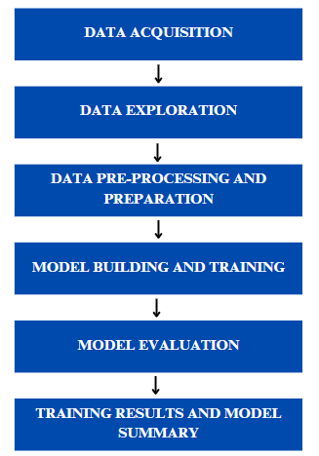

Fig. 1. Methodology flowchart

*A. Data acquisition:*

The image dataset is collected from Kaggle, an open-source repository of datasets. The dataset contains 2 folders. One of the folders contain the ultrasound images of PCOS infected ovaries and the other folder contains ultrasound images of non-infected healthy ovaries.

There are more than 500 sample images for each class – infected and non-infected, which allows for optimal results after training on the image data.

The below figure 2a and 2b depict the ultrasound images of PCOS infected ovaries in women and figure 3a and 3b depict the ultrasound images of non-infected (healthy) ovaries in women.

*1) PCOS infected ovaries – Ultrasound image samples:*

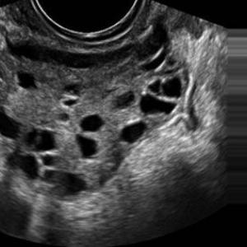

Fig. 2. Infected image (A)

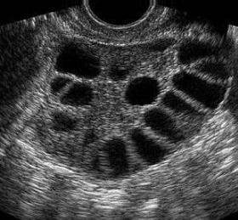

Fig. 3. Infected image (B)

*2) Non-infected (Healthy) ovaries – Ultrasound image samples:*

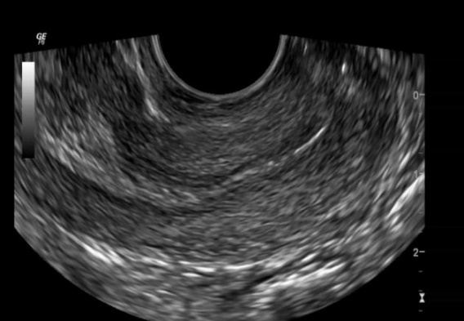

Fig. 4. Non-Infected image (A)

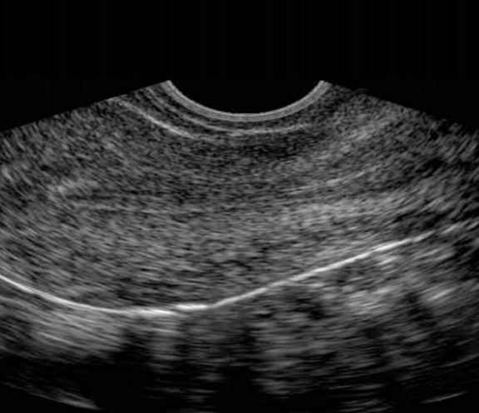

Fig. 5. Non-Infected image (B)

*B. Data exploration:*

During the data analysis phase, an assortment of ultrasound images portraying ovarian morphology is employed for identifying Polycystic Ovary Syndrome (PCOS) [9]. This dataset encompasses images sourced from individuals both positive and negative for PCOS. Through exploratory data analysis (EDA) [10], the investigation delves into understanding the distribution of classes, dimensions of the images, and possible imbalances within the dataset. Descriptive statistical measures [11] like mean, median, and standard deviation are computed to gain deeper insights into the characteristics of the images.

*C. Data pre-processing and preparation:*

Pre-processing stands as a pivotal phase in readying the data for training deep learning models. A range of pre-processing methods is administered to the ultrasound images, encompassing resizing to a consistent dimension (e.g., 224x224 pixels), conversion of RGB images into grayscale, augmentation [12] [8] of the dataset through operations such as shearing, zooming, flipping, and rotation, alongside normalization of pixel values to a scale spanning from 0 to 1.

*D. Model building and training:*

A variety of Convolutional Neural Network (CNN) models are created and trained using the pre-processed ultrasound images [5] [9].

There are five models built for the evaluation of the CNN model for the trained data.

Activation Functions that have been used are:

*1) Convolutional Layers****:*** ReLU (Rectified Linear Unit) activation function is used for convolutional layers in all models (activation='relu'). ReLU is commonly used in CNNs for its simplicity and effectiveness in capturing non-linearities.

*2) Dense Layer (Output Layer):*The output layer of each model uses softmax activation (activation='softmax') for binary classification (PCOS-positive and PCOS-negative). Softmax is suitable for multi-class classification tasks as it outputs probabilities for each class, aiding in decision-making.

The model architecture has been described below for each model.

*1) Model 1:*This model is a convolutional neural network (CNN) architecture designed for the task of PCOS detection using ultrasound images. It starts with a Conv2D layer with 10 filters of size 5x5, followed by a MaxPooling2D layer with a pool size of (4,4) to reduce spatial dimensions [3]. This combination helps in capturing important features from the input images while reducing computational complexity. Another Conv2D layer with 12 filters of size 5x5 is added, followed by another MaxPooling2D layer. The Flatten layer converts the multidimensional output from the convolutional layers into a 1D array, which is then fed into a Dense layer with 2 output units and a softmax activation function for binary classification (PCOS-positive and PCOS-negative).

*2) Model 2:*This model is similar to Model 1 but with some variations in filter sizes and pool sizes. It starts with a Conv2D layer with 12 filters of size 6x6 and a MaxPooling2D layer with a pool size of (6,6). This configuration may capture different spatial patterns compared to Model 1. It also includes additional Conv2D layers with different filter sizes and pool sizes, followed by a Flatten layer and a Dense layer for classification.

*3) Model 3:*This model follows a similar architecture to Model 1 and Model 2 but introduces additional Conv2D and MaxPooling2D layers. These additional layers allow the model to learn more complex features and patterns from the input ultrasound images. The final layers of Flatten and Dense for classification remain consistent with the previous models.

*4) Model 4:* This model is another variant with variations in filter sizes, numbers of filters, and pool sizes. These variations impact how the model extracts and processes information from the input images. By experimenting with different configurations, Model 4 aims to optimize the feature extraction and classification process for PCOS detection.

*5) Model 5:*This model continues the experimentation by changing filter sizes, pool sizes, and numbers of filters in the Conv2D layers. These changes may influence the model's ability to generalize and make accurate predictions on unseen data. The overall architecture, including Flatten and Dense layers, remains consistent with the previous models.

These models showcase diverse architectures [2] with unique configurations of convolutional layers, pooling layers, activation functions, and dense layers. Each model uses a sequence of layers to analyze the input images, identify patterns, reduce unnecessary details, and make a prediction about whether the ovary is infected or not. The differences between the models lie in how many layers they have, the settings of those layers, and how they process the information. Throughout the training process, optimization techniques like Adam and loss functions such as Categorical Cross entropy are applied.

*1) Adam Optimizer:* Adaptive Moment Estimation is a popular optimization algorithm that combines the benefits of both AdaGrad and RMSProp. It adapts the learning rates for each parameter based on the average of their past gradients and squared gradients. Adam is known for its effectiveness in training deep neural networks efficiently and handling sparse gradients.

*2) Categorical Cross Entropy Loss:* It is a common choice for multi-class classification problems, where the target variable has multiple classes. It measures the dissimilarity between the predicted probabilities and the true distribution of class labels. In the context of the described models, Categorical Cross Entropy loss is used during the training phase to compute the loss and update the model parameters based on the gradients.

The training phase involves multiple iterations over the dataset spanning numerous epochs. During this iterative process, key metrics such as accuracy and loss are continuously monitored to refine and optimize the models, ultimately aiming to achieve superior performance and predictive accuracy.

*E. Model evaluation:*

Following the completion of training, the constructed models undergo rigorous evaluation using unseen test data to thoroughly gauge their predictive prowess. This evaluation process is paramount in accurately assessing the models' capabilities in discerning between PCOS-positive and PCOS-negative cases [9]. Various evaluation metrics such as training accuracy, training loss, validation accuracy and validation loss are meticulously computed to provide a comprehensive analysis of the model's performance [4]. Moreover, in-depth assessments are conducted to delve into the model's predictive accuracy concerning specific classes, ensuring robustness across different classifications.

III. TRAINING RESULTS AND MODEL SUMMARY:

*1) Model 1:* Achieved 97.9% validation accuracy on training and validating data after 5 epochs. It is relatively simple with a total of 7230 trainable parameters. Despite its simplicity, it performs remarkably well on the given dataset.

Figure 4 depicts the graphical representation of loss values during training and validating process of this model.

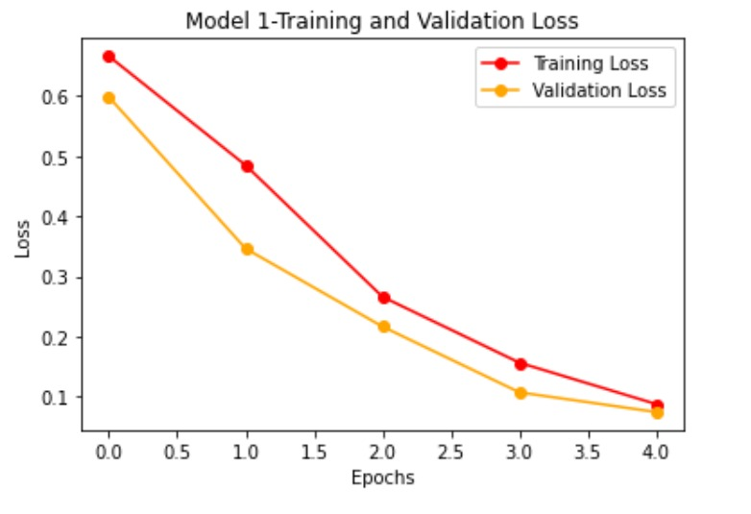

Fig. 6. Graph of Training and validation loss in model 1

*2) Model 2:*Achieved 98.6% accuracy on training and validating data after 8 epochs.It contains 10152 trainable parameters, which is slightly more than Model 1 but still manageable.

Figure 5 depicts the graphical representation of loss values during training and validating process of this model.

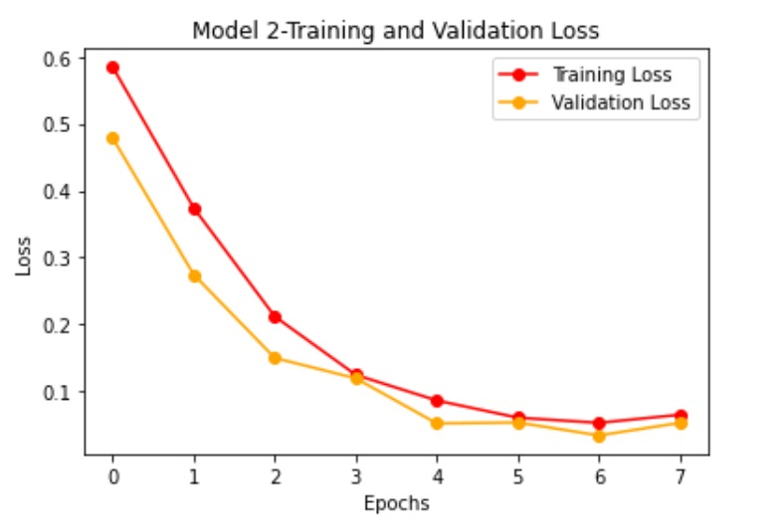

Fig. 7. Graph of Training and validation loss in model 2

*3) Model 3:*Achieved 94.7% accuracy on training and validating data after 6 epochs. This model resulted in 8545 trainable parameters which is slightly more parameters compared to Model 1 but less than Model 2.

Figure 6 depicts the graphical representation of loss values during training and validating process of this model.

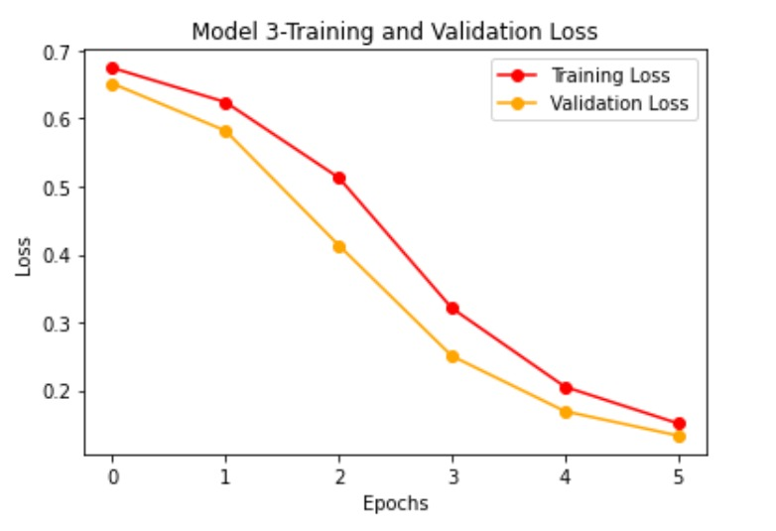

Fig. 8. Graph of Training and validation loss in model 3

*4) Model 4:*Achieved 97.4% accuracy on training and validating data after 10 epochs. This model is similar to Model 3 but with different filter sizes in the convolutional layers.

Figure 7 depicts the graphical representation of loss values during training and validating process of this model.

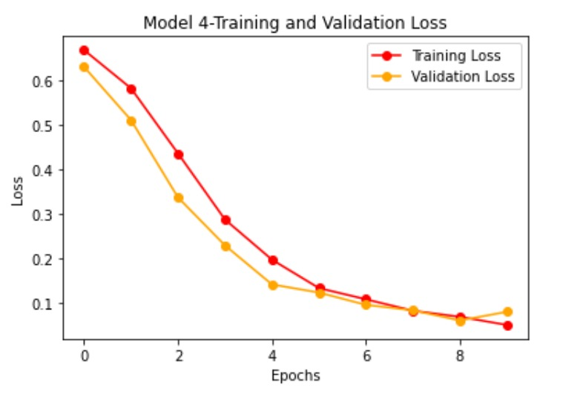

Fig. 10. Graph of Training and validation loss in model 4

*5) Model 5:*Achieved 96.8% accuracy on training and validating data after 6 epochs. Similar to Model 2 but with different filter sizes in the convolutional layers, resulting in 10658 trainable parameters. It achieves good accuracy but has slightly more parameters compared to Model 2.

Figure 8 depicts the graphical representation of loss values during training and validating process of this model.

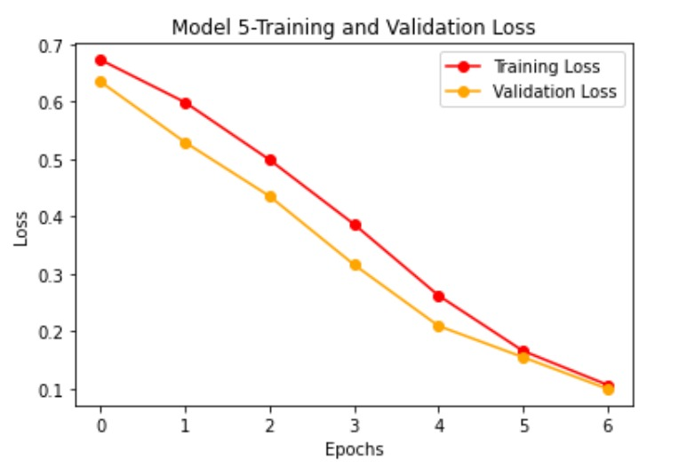

Fig. 9. Graph of Training and validation loss in model 5

These matrices offer insightful visualizations, allowing for a detailed examination of the model's strengths and areas for improvement, ultimately contributing to enhanced diagnostic capabilities in detecting Polycystic Ovary Syndrome (PCOS).

IV. INSIGHTS & ANALYSIS

In this study, the effectiveness of convolutional neural network (CNN) models for image prediction of Polycystic Ovary Syndrome (PCOS) have been explored. Five different CNN architectures were implemented and evaluated. Model 2 emerged as the most robust and accurate among the models, achieving an impressive accuracy of approximately 98.6% after 8 epochs of training. It is noteworthy that Model 4 also performed exceptionally well, with an accuracy of about 97.4%, showcasing the effectiveness of its architecture. While Model 2 and Model 4 demonstrated high accuracy, they differ significantly in complexity. Model 2 has a higher number of trainable parameters compared to Model 4, making it computationally more intensive. This highlights the trade-off between model complexity and accuracy, where Model 4 provides a compelling balance.

Model 1, although simpler in architecture, also showed promising results with an accuracy of around 97.6%. This suggests that even moderately complex CNN models can yield accurate predictions for PCOS image classification tasks. On the other hand, Model 3, with the simplest architecture among the models evaluated, achieved an accuracy of approximately 93.5%. While its performance is slightly lower compared to the other models, it demonstrates that even basic CNN architectures can provide valuable insights in image prediction tasks.

**V. CONCLUSION AND FUTURE WORK**

*1) Conclusion:*

In summarizing the exploration of CNN models for PCOS prediction from ultrasound images, crucial insights have been gained. Model 2 emerged as the standout performer with an impressive 98.6% accuracy, highlighting the significance of finely tuning architectural parameters for optimal results. Conversely, Model 4, despite its simplicity, achieved a commendable 97.4% accuracy, indicating effective design with fewer parameters. This underscores the delicate balance between model complexity and accuracy, where Model 2 demonstrated higher accuracy at the cost of increased computational demands, while Model 4 achieved respectable performance with reduced complexity. The findings of this study underscore the efficacy of CNN models in accurately predicting PCOS from image data. The choice of model architecture should be guided by considerations such as accuracy requirements, computational resources, and model complexity. This study contributes to the growing body of research in medical image analysis and lays a foundation for developing more sophisticated and accurate predictive models for PCOS diagnosis and monitoring.

*2) Future work:*

Exploring multi-modal fusion techniques by integrating additional data modalities, such as patient clinical data or hormonal profiles, along with ultrasound images, could provide a comprehensive understanding of PCOS and enhance prediction accuracy.

Future studies may consider incorporating transfer learning techniques by utilizing pre-trained CNN models like ResNet, VGG, or Inception. These models are trained on extensive image datasets like ImageNet. Fine-tuning these models with ultrasound images related to PCOS could improve model performance by transferring previously learned features and patterns, contributing to better predictions.

Conducting real-world deployment studies by integrating the developed CNN models into clinical practice settings, followed by proper validation and evaluation, would provide valuable insights into the models' performance in real-time scenarios and their impact on clinical decision-making.

**REFERENCES**

1. Joham AE, Norman RJ, Stener-Victorin E, Legro RS, Franks S, Moran LJ, Boyle J, Teede HJ. Polycystic ovary syndrome. The lancet Diabetes & endocrinology. 2022 Sep 1;10(9):668-80.
2. Khan A, Sohail A, Zahoora U, Qureshi AS. A survey of the recent architectures of deep convolutional neural networks. Artificial intelligence review. 2020 Dec;53:5455-516.
3. Wang ZJ, Turko R, Shaikh O, Park H, Das N, Hohman F, Kahng M, Chau DH. CNN explainer: learning convolutional neural networks with interactive visualization. IEEE Transactions on Visualization and Computer Graphics. 2020 Oct 13;27(2):1396-406.
4. Dalianis H, Dalianis H. Evaluation metrics and evaluation. Clinical Text Mining: secondary use of electronic patient records. 2018:45-53.
5. Sumathi M, Chitra P, Prabha RS, Srilatha K. Study and detection of PCOS related diseases using CNN. InIOP Conference Series: Materials Science and Engineering 2021 Feb 1 (Vol. 1070, No. 1, p. 012062). IOP Publishing.
6. Shahid R, Mahnoor, Awan KA, Iqbal MJ, Munir H, Saeed I. Diet and lifestyle modifications for effective management of polycystic ovarian syndrome (PCOS). Journal of Food Biochemistry. 2022 Jul;46(7):e14117.
7. Copp T, Muscat DM, Hersch J, McCaffery KJ, Doust J, Dokras A, Mol BW, Jansen J. The challenges with managing polycystic ovary syndrome: a qualitative study of women’s and clinicians’ experiences. Patient education and counseling. 2022 Mar 1;105(3):719-25.
8. Hao R, Namdar K, Liu L, Haider MA, Khalvati F. A comprehensive study of data augmentation strategies for prostate cancer detection in diffusion-weighted MRI using convolutional neural networks. Journal of Digital Imaging. 2021 Aug;34:862-76.
9. Hosain AS, Mehedi MH, Kabir IE. Pconet: A convolutional neural network architecture to detect polycystic ovary syndrome (pcos) from ovarian ultrasound images. In2022 International Conference on Engineering and Emerging Technologies (ICEET) 2022 Oct 27 (pp. 1-6). IEEE.
10. Mukhiya SK, Ahmed U. Hands-On Exploratory Data Analysis with Python: Perform EDA techniques to understand, summarize, and investigate your data. Packt Publishing Ltd; 2020 Mar 27.
11. Kaur P, Stoltzfus J, Yellapu V. Descriptive statistics. International Journal of Academic Medicine. 2018 Jan 1;4(1):60-3.
12. Cossio M. Augmenting medical imaging: a comprehensive catalogue of 65 techniques for enhanced data analysis. arXiv preprint arXiv:2303.01178. 2023 Mar 2.